LOSE YOUR MIND
Mental Health Literacy Workshops
Jasper & Poweshiek Counties, Iowa, USA.
May 6th – 17th 2019

TABLE OF CONTENTS

1. GRANT 1
2. WORKSHOPS 2
3. STAFFING 3
4. ATTENDEES 5
5. FEEDBACK 5
6. LETTER OF RECOMMENDATION 14
7. PHOTOS 15

EVENT REPORT

GRANT
LOSE YOUR MIND Active Mental Health Literacy Workshops were brought to Iowa by Kelly Yeggy. Organizer of the Zac Yeggy Foundation (ZYF). The ZYF was created to honour Kelly's son Zac, who took his own life on August 22, 2017 following a six year battle with bipolar disorder. Fighting negative stigma that surrounds mental illness is one of ZYF's primary goals and LOSE YOUR MIND provided an insight as to what someone with mental health issues is experiencing. Insight into another's struggles creates empathy; empathy overcomes stigma. After receiving a grant from the Central Iowa Community Services (CICS) Mental Health Region, ZYF's desire to bring the innovative LOSE YOUR MIND Workshops to Iowa was realized. In partnership with Capstone Behavioral Health Care clinical staff, workshops were held in central Iowa over a two week period of time. LOSE YOUR MIND's impact on the citizens who participated in the workshops exceeded all expectations and teacher's, law enforcement, mental health services providers, etc. referred to this as the best mental health training they have attended.

WORKSHOPS
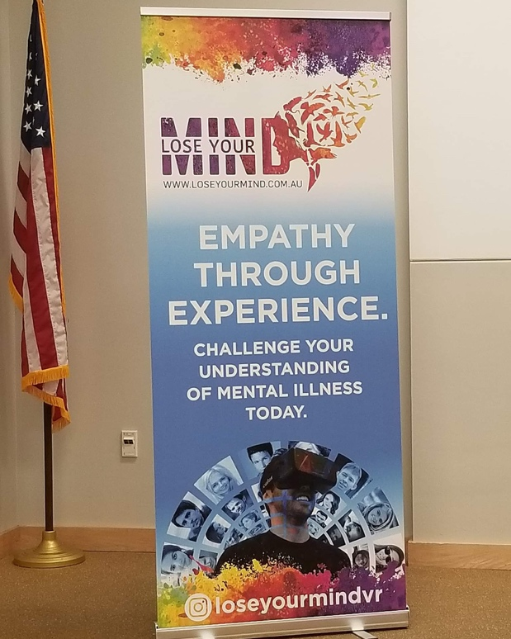
LOSE YOUR MIND mental health literacy fundamentals workshops are designed for anyone (professionals and the general public) who would benefit from an emotionally engaging, empathy-driven discussion about mental illness (and psychosis in particular) and the best strategies for compassionate communication and early intervention.
Using a Virtual Reality simulation, participants were fully immersed into the experience of a young person having a psychotic episode. Following this uniquely emotional and challenging experience they explored effective techniques for communication with empathy, curiosity and kindness. Content was delivered via PowerPoint slides, group discussion and activities.
Overall, there was great engagement and discussion between participants within the workshops and positive feedback afterwards (see 5. Feedback below).
Course Outline:
- VR simulation.
- Personal reflection & sharing activity.
- Information about psychosis / mental illness (what causes it, and how it might get worse or be maintained over time if not treated)
- Information about evidence-based treatment for psychosis (what do we know works?)
- Strategies for talking to someone who might be experiencing a psychotic episode / mental illness (how to help them feel safe and heard).
- Communication activities / case studies.
- Strategies for self care.

STAFFING
Leanne Butterworth, Founder of LOSE YOUR MIND facilitated the workshops.
Dr Jennifer Wilson, Clinical Psychologist, trained Amanda Johnson (Psychologist) and Jana Brown (Social Worker) via Zoom who presented the workshops in Iowa with Leanne. On two occasions, Dr Wilson conducted the workshops via Zoom when Amanda and Jana weren’t available.
Kelly Yeggy project managed the tour and administrated the workshops.
Biographies
Leanne Butterworth Founder LOSE YOUR MIND  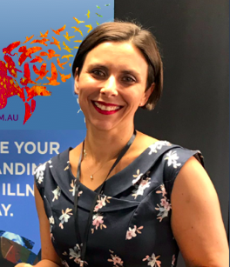 | Leanne Butterworth is a mother of two, Rowan (8) and Zara (7), has a degree in Applied Science and a Graduate Certificate in Business (Nonprofit and Philanthropy Studies). She is a George Alexander Foundation Scholar, won the 2018 QUT Entrepreneurship UberCamp award and was invited to showcase LOSE YOUR MIND to His Royal Highness, Prince Andrew, the Duke of York. She is also a member of the 10th Impact Academy Social Enterprise Accelerator.  LOSE YOUR MIND was borne of a place of disconnection. Leanne suffered from postnatal depression in her late thirties and felt she had nobody who truly understood what she was going through, feeling and thinking. She felt isolated and alone. Most people think they know what mental illness IS, but Leanne decided to give people the experience of what mental illness is LIKE.
Kelly Yeggy  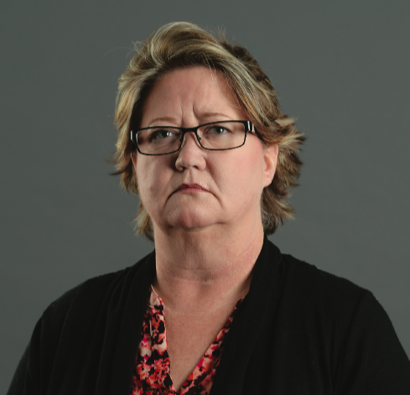 | Kelly Yeggy is a Judicial Mental Health Advocate for Polk, Jasper & Marion Counties at Greater Newton Area Chamber of Commerce. On August 22nd, 2017, Kelly’s loving son Zac took his own life after a six year struggle with bipolar disorder. Kelly blames stigma for his death and set up the Zac Yeggy Foundation in his honour.  The Zac Yeggy Foundation is committed to discovering innovative programs to fight mental health stigma. Stigma causes denial of illness, delays in accessing treatment and frequently prohibits active participation in treatment services. We believe that mental health is an issue that concerns us all and impacts a significant portion of the population directly or indirectly. Furthermore, mental wellness is a topic that is as important as staying physically healthy and fit.  Kelly made it her mission to bring LOSE YOUR MIND to Iowa.
Dr Jennifer Wilson  B Psych (Hons)  PhD (Clin Psych) MAPS  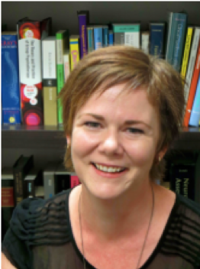 | Dr Jennifer Wilson is a Brisbane-based clinical psychologist working in private practice. Her doctoral thesis examined the development of children’s thinking and reasoning skills. Jennifer works with people having difficulty with a broad range of mental health and life challenges, but has special interests in helping people experiencing psychosis to understand and cope with their experiences. Jennifer also maintains an active interest in applied and academic research, including the translation of evidence-based treatments for psychosis to existing mental health services.
Amanda Johnson  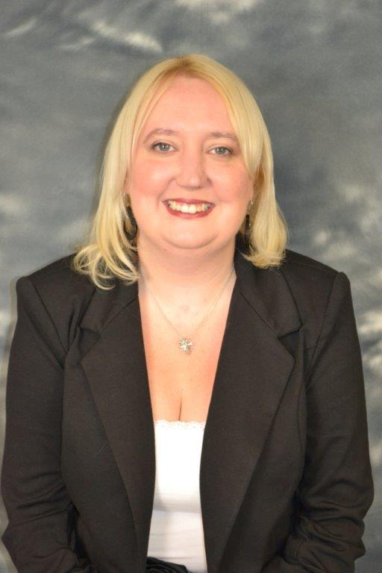 | Amanda Johnson, PhD is a psychologist and clinical director of Capstone Behavioral Healthcare in Newton and Grinnell, IA. She received her doctorate in Counseling Psychology from the University of New York at Buffalo in 2010. She has worked in multiple settings including community mental health, Veteran’s Hospitals, and a college counseling center. She also has experience teaching at both the undergraduate and graduate level. She enjoys working with clients of all ages and some of her clinical interests include trauma, grief and loss, and multicultural issues. She is currently researching development of technology to assist those who may be contemplating suicide.
Jana Brown  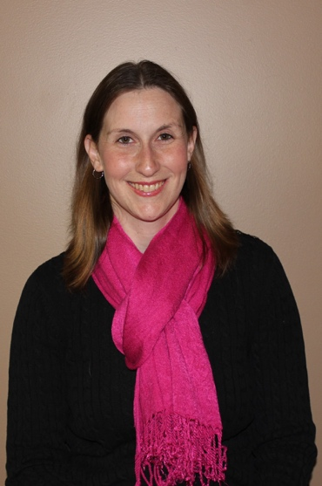 | Jana Brown is a Licensed Independent Social Worker. She is currently the Intake Specialist at Capstone Behavioral Healthcare in Newton, Iowa. Jana has her Bachelor of Arts from the University of Iowa in Social Work and Psychology. She has her Masters of Social Work from St. Ambrose University. Jana has over 10 years of clinical social work experience. She has served on the National Association of Social Work Iowa Chapter Board. Jana has also been a Mandatory Reporter Trainer. In her free time, she enjoys spending time with her husband and dogs, going to Cubs games, reading, traveling, and visiting her friends and family in Chicago.

ATTENDEES
Over 210 attendees participated in 18 workshops and 4 drop in sessions in the towns of Newton, Colfax, Marshalltown, Grinnell, Knoxville and Des Moines. A wide variety of professions were represented including police, crisis workers, teachers, nurses, guidance officers, principals, librarians, parents, psychologists, receptionists, CEOs, GPs and fire fighters.

FEEDBACK
Participants were asked to fill out questionnaires on FOUR occasions:
- prior to the VR experience, including waivers,
- immediately after the VR experience,
- at the end of the workshop,
- within a month after the workshop.
A snapshot of responses can be found below.
A follow up questionnaire will also be conducted at 6 months post-workshop to gauge a change in attitude, behaviour and conditions.
Pre-Workshop Questions
Prior to the workshop, participants were asked to define their expectations for the day:
- To understand what our clients deal with daily
- Become more empathetic
- Got a better idea of what others see with severe MI
- Insight into the issues my clients experience
- Learn more details of psychosis, how to approach conversations
- To be more compassionate & understand more
Post-VR Questions
How did you feel after the VR?
- Confused, scared, traumatized, over stimulated
- Uncomfortable, stressed, increased heart rate
- I need a cigarette. Very overwhelming
- Anxious, exhausted
- A little stressed out - overwhelmed - a little anxious
- That I need to go to a quiet place alone
- It was eye opening. I was glad it was over. It was exhausting
- Empathetic for someone that goes through this & thankful that I don't experience this
- Anxious, confused, not really interested in everything else. Feeling of being alone

Post-Workshop Questions
What do you feel is the benefit of your participations in today’s workshop?
For yourself?
- Being able to have more empathy & understand what patients struggling w/MI really need
- Two of my children have issues (mild autism the other ADHD & this gives me better understanding that their actions/reactions aren't always fully their choice
- Understanding that the person needs comfort, reassurance
- Have a family member struggling w/mh challenges
- I would hope to be better at communicating with people in need
- it described me 100%
- realize I don't always have to fix to listen, not judge
- Better understand that they cannot think straight unable to understand people trying to reason with them
- more easily be able to speak to students dealing w/MH
- learning to ask question/comments in a more empathetic manner. Being a better listener.
- My wife struggles w/depression & a friend of mine struggles w/anxiety. This workshop helps.
- These were good reminders of validating what someone is feeling and thinking and just supporting them
- Learned not to use just and/or should in response to someone's struggles
- I have a son who suffers from anxiety & am looking to be more supportive
- I feel w/the experience at this workshop to model empathy to our students will be my personal benefit & demonstrate it as leadership w/out team
- More thoughtful questions for my students
- more compassionate
- reduce my frustration in interactions
- I have learned how to reframe questions to promote a healthy safe space for my clients
- Be able to provide the right response to a client in psychosis
- Personal expansion of knowledge is a positive thing
- being better prepared to assist the individuals that I work with - I feel more comfortable and able to have confidence to do the right thing

For your students / clients?
- Hopefully they feel more understood
- I am hopeful if someone presents a problem to me I can better help them.
- I hope I am able to use this sometime and change their trust
- I hope it helps to make people feel safe while with me
- I hope it will make clients feel like they are able to speak more openly about issues w/me
- more empathy….a safe place
- They will feel like you do care and are here to help them
- Yes, treating them the way to deserve as opposed to passing them off onto the next person

For your school / company?
- Yes, give people hope that are suffering & educate our environment/community which in turn leads to lessen MH stigma
- I feel that I can decrease the negative association w/MI as a leader in our team
- Talk openly about MI-lower stigma in our society
- will try to build trust & support - so others can feel connected, validated, supported & heard
- Reducing stigma, increasing understanding
- Yes, I will pass this information on and hopefully make someone feel safe & then they will pass it on.
- Lessening the stigma, law enforcement having more compassion, more understanding
- Yes. My community will hopefully benefit
Other feedback

- Absolutely loved this. It was so insightful to see what a MH person is really going through
- Awesome! Keep the energy up!
- Could be expanded for a longer period of time
- A continued follow up class for this would be great. I think that would be helpful.
- Everyone should do this
- Great presentation, excited to be a part of it
- Great training. Probably the best one - most interactive training ever!
- Have one for parents or co-workers - not necessarily people in the profession
- I appreciate it so much I think I've really learned, very helpful.
- I loved this training. Very insightful, Thank you!!! Thank you!!! Thank you!!
- I needed to be here today this is my life and my career.
- It will also help in my personal life w/my mom who struggles w/MH, addiction, & multiple suicide attempts. Experience is the best way to understand other people & best support them.
- Keep doing what you are doing you are amazing
- Loved the case work help. Focus on Compassion, care, empathy for clients, rather than focusing on symptoms.
- Schools, law enforcement, jails, etc. need this training
- Thank you! Lots of 'food for thought'.
- Thank you for the opportunity & experience
- Thank you so much! What a gift this training was & thank you for funding it.
- Thank you so much. I truly wish I had this information when my son was 14. The 'Steve ‘example is very true of my situation 6 years ago.
- Thanks for coming today, you were amazing!
- This was very enlightening & gives me many things to consider & ways to handle our position
- Very thankful that Leanne was able to come & provide the training. I hope that her technology & program can be shared all over.
- Very worthwhile - great for friends, family and crisis workers
- We need more of this, also thank you to Kelly

One-month survey data
The response rate of surveys was 50% (95/190) which is considered an excellent result. Surveys were emailed out using SurveyMonkey.
The survey results below include responses from participants in both the full workshop (n=85) and the drop in sessions (n=10). Drop in sessions received only the VR simulation and an overview of the training with an emphasis on empathetic communication styles.
A full report of all survey data is also available.
MULTI CHOICE QUESTION – What do you feel you learnt at the workshop (please choose all that apply)?
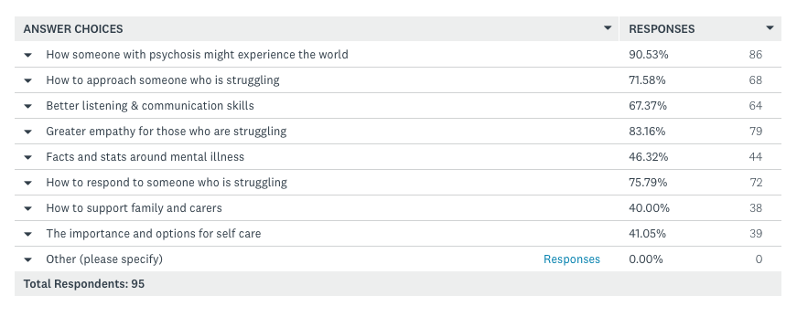
OPEN ENDED QUESTION - Does anything from the workshop stand out in your mind (a fact, experience, new way of thinking etc)?
Answers from this question have been summarised in a word cloud.
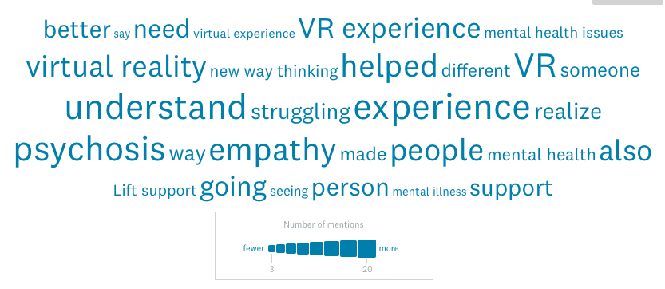
- Empathy as opposed to sympathy, while it wasn't a new way of thinking, it played out in a way that drove it home better than anything else I've read or experienced in the past.
- Experiencing a psychotic episode via VR
- Experiencing what the student may go through.
- Greater understanding and empathy for those struggling. VR was quite an eye opener!
- Having more empathy for those with mental health issues
- How hard it was to focus when there are other voices in your head.
- How important it is to empathize with the person who is experiencing psychosis.
- How incredibly difficult it was to focus on the speaker during the VR experience.
- How NOT to talk to someone who is struggling with mental health issues. How to be empathetic and supporting of them.
MULTIPLE CHOICE QUESTION - How has improving your mental health literacy (including the VR experience) influenced your relationship with your students, clients or peers? (please choose all that apply)
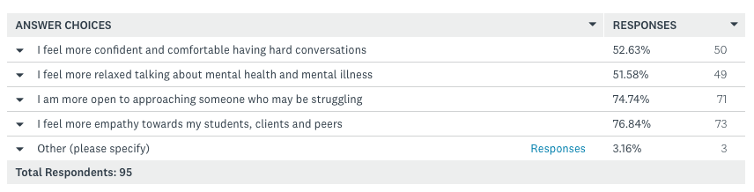
Other:
- The VR helped me understand more
- I am a counselor so I am used to doing all of these things and feel comfortable in general talking with students about anything, even the hard stuff.
- Easier to understand subject when dealing with them in Police work.
OPEN ENDED QUESTION - Can you provide an example of where you have been more empathetic, understanding or better at communicating with someone who is struggling with their mental health?
- Having a brother-in-law who suffers from mental illness I used to look at his action as a choice but now I see that this is his reality and not a choice he has made.
- I am a better listener when people are talking about their mental health and have been able to comfortably ask them if and how I can help them.
- A student said she was having very concerning self-harm and suicidal thoughts. She said I made her feel like she wasn't alone after speaking with her.
- I give them a safe space, we talk, we breathe, do whatever is needed to help them at the time
- I have been taking my time to listen more carefully to what is being said, whenever a situation is not understood after a couple of time, not to get frustrated and explain it in a different way.
- I have been using an invitation to suggest help for clients, instead of telling them what they "should" do
- I have chosen to respond to students struggling with self-regulation in a more subtle way. In the back of my mind I keep the thought that each student could be suffering a mental illness each day.
- I have not been afraid to approach the subject with a patient. And no know not to say I am sorry that has happened to you, but to let them know that some things he/she has experienced would make anyone struggle and that struggling is a normal experience and there is help.
- I just closed my mouth and listened (for once :).
- I understand more that some people who struggle with mental health issues can't just "pull it together and act right " for the sake of getting their children returned home.
- I was more cautious and soft spoken when working a student, who suffers from periods of mental health issues and really tried to listen and ask questions to help the individual improve their current reality of life and what it should look like for them to be a better learner in overcoming the obstacles associated with mental health issues.
- I was no longer frightened when a client called and said she was suicidal. I went to her and assisted her in getting immediate professional help and care.
- I was tempted to say "just" relax. Instead I invited them to take break with me. We strolled and talked.
- I work with mobile crisis, so there have been several calls I've been on since the workshop... It has been easier to connect with people vs just seeing it as just another call.
- I've been helping a woman who is bipolar but has been off her meds for a couple of months. Understanding the confusion and mixed signals she was getting helped me be more empathic and patient with her as we tried to work through what needed to be done to get her back to a more stable state of getting to the doctor and meds.
- I've make it a point to reach out, invite to chat & do a favorite activities together. Listening more. Let her know I am available if she needs someone to talk to.
- Improved awareness when working one on one with someone to watch for signs that they may be uncomfortable for reasons that are not easily noticed. Also, a new willingness to just ask someone if they are okay or if they need help in anyway.
- Just being able to have a meaningful conversation with the students who are struggling. They are relieved to find someone who acknowledges their struggles in a safe way with an openness that facilitates a line of communication that is supportive to their needs no matter how large or small
- letting them know that it is OKAY to seek help when you are struggling, doesn't make you weak, but stronger in the end
- Meeting people where they are and to not “silver Line” struggles.
- More empathy instead of anger.
- My daughter struggles with her mental health and since the workshop I have been able to slow down, step back, and really try to help her through it instead of just “defusing”
- My son struggles with mental health and I feel this workshop gave me some great tools in talking to him and understanding him better.
- Responding by simply saying, "I don't know what to say."
- Shortly after attending the workshop, a client experienced his first psychotic break. He was very combative in session and accusing me of having him followed/monitored etc. and being in on a conspiracy to make him sick. The recent focus on empathy from the workshop put me in a place to react to the fear instead of taking offense to his accusations or feeling defensive.
- So far it has assisted with my relationships with my children when they are acting out or having behavioral issues.
- Speaking with my sister who suffers from bipolar with schizoaffective tendencies, I have tried to listen more and not argue with her or try to convince her of reality.
- There are a number of people who come to my workplace who we get an opportunity to serve human to human, and having a better understanding to what they might be experiencing helps to see them and work with them with less apprehension.
- There are times when we think of someone struggling to just pull themselves up by their bootstraps and get on with their life. But many people dealing with psychosis are unable to know how to pull themselves up. This workshops helps to meet people where they are.
- There is a female that has arrest warrants constantly who suffers from Schizophrenia and I have counted at least 9 different people she’s talking to. I just simply ask her who she is talking to and what their names are. She seems to calm down after I make small talk with her.
- When interacting with patients I try to be more open to the fact that they may be dealing with unseen side effects that effect the way they are able to communicate with me.
- When my son had an anxiety attack, I approached it with more compassion.
- When people call in and want to be seen right away, I try to find an opening for them as an emergency session. I realize that it took a lot of courage for them to even pick up the phone and call for help, so I really try to go out of my way to help them
- When speaking with a person experiencing psychosis I try to keep my experience in the back of my mind to help them deal with their crisis
- Working in the community and jail, I am the first face many folks see before they get engaged in mental health services. There have been several times folks would tell me about things they were believing to be true; I was able to respond in a more honest approach rather than agreeing with their beliefs.
- Working part time in a group home. One of the clients clearly had severe mental health issues. It has helped me be more tolerant. Sometimes it is easy to think the client is just "annoying". It helps to understand they really can not help some of the things they do or say.
OPEN ENDED QUESTION - Do you feel your participation has positively influenced those around you and the mental health culture / stigma at your school, workplace or in daily life? If so, how?
- Yes. It has helped have an open conversation with coworkers
- Yes, because I have been sharing about it with those not in the mental health field and they have been more interested in learning about it.
- Yes, I gained more empathy from being in the workshop!
- I talked about how informational it was and suggested that everyone get a chance to do this.
- I feel like myself and my coworkers have a better understanding of our clients.
- Helped with being open about mental health issues at work
- For myself I am putting more effort into being aware of how others are interacting or isolating in various areas of work, family and public. I hope others become aware and make changes as well.
- Yes, I brought back the information and shared it with my coworkers. They said it helped give them a different perspective also
- Yes, I was able to share what I learned with my colleagues.

OPEN ENDED QUESTION – Do you have any other feedback or suggestions you would like to add?
- A very good learning experience. I am a Supervisor so I don't work with this, but have dealt with it in family members. It has made me deal with them in a more positive way.
- Amazing presentation.
- Every police dept in state of Iowa needs to attend
- Everyone could benefit from this training! Keep doing what you're doing!
- Excellent class and presentation.
- Great job with virtual reality experience and providing discussion time to debrief and help us learn to deal with students suffering from mental health issues.
- Great teaching skills to both instructors.
- Great workshop. Wish every student could experience it.
- I appreciated Leanne's and Kelley's personal truths, stories and accounts around their own lives. That helps to bring mental health back to the forefront.
- I felt that while the workshop was very good, too much emphasis was placed on the clinical information that was presented remotely via skype or facetime. I would have preferred more time spent going through role-play scenarios so we could have simulated discussions with students who may be dealing with mental illness.
- I found the experience very fun and helpful. I did not get much from the VR, but the conversation around empathy and communication was great.
- I think Amanda and Leanne made a great team! I really enjoyed the session!
- I think this is a great tool for helping people understand how psychosis can affect our fellow citizens, family members and friends. Hopefully this is an event that gets brought to the general public and not just people who work in the field.
- I think you did an awesome job! I took a lot form that training and will never forget. Thank you
- I thought it was a great workshop. Very helpful and insightful.
- I thought the session was outstanding!
- I would just like to say a big THANK YOU for coming all the way to Iowa to hold this workshop for us. It was just an incredible experience.
- I would love to see something like this offered in all schools and workplaces to have more empathy and compassion towards others.
- I would very much like to visit this topic in a session like this one maybe with other kinds of mental illness and how to respond to coworkers who may be going through a hard time.
- Keep going! What you are doing is important and life giving!!
- Leanne did a great job doing the demonstration and workshop, her heart was in it!!!
- Leanne was a great presenter!
- Maybe you are already doing this, but, if feasible, it would be good to keep in touch with your program participants with an weekly or monthly "tip" or strategy for better communication with those struggling with mental illness.
- No. This was a very enlightening and life changing experience for me.
- Please keep up what you are doing. It is so needed in our world and will help so many people if you can get it out there.
- Such an amazing presentation. I enjoyed it and it was definitely one of those "Classes" or sessions that I could have sat all day at.
- Thanks for hosting this . I felt very enriched
- This class was a great experience and wish more Law Enforcement officer could experience it. As mental illness is a growing issue that we deal with on a daily basis.
- This training was much more than I anticipated in a good way. I would recommend it to everyone. I have family members that I wish could have attended.
- This was the best training I have had the privilege to attend. As a provider we only see what they present on the outside and what is not going on internally this. This gave insight to just what a person could be internalizing.

LETTER OF RECOMMENDATION
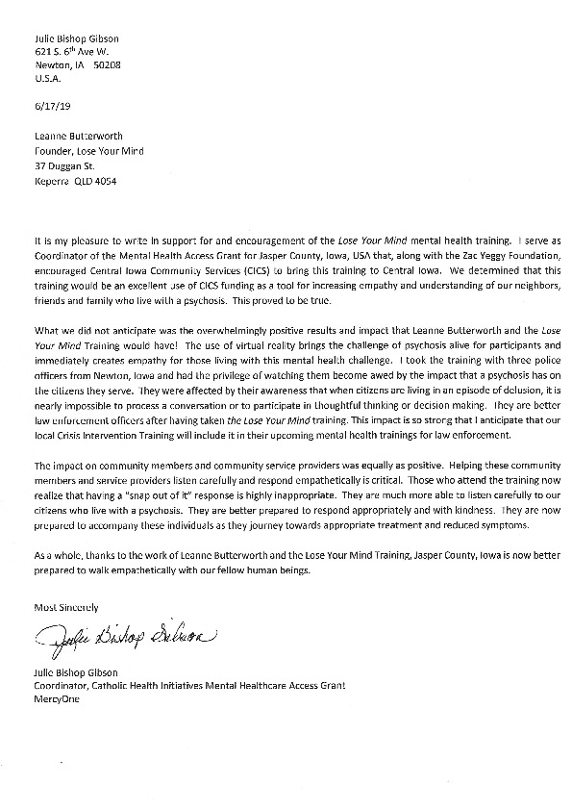

PHOTOS
